Busy Bees
Pre-School

Prospectus

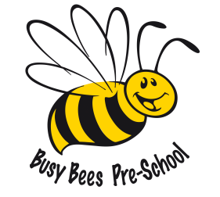

Bishops Sutton Village Hall
Main Road, Bishops Sutton, Hampshire. SO24 0AA
Tel: 01962 809918 session time or Debbie’s mobile: 07815166687 at any other time.
Email: busybeespreschoolteam@hotmail.com

Welcome to Busy Bees Preschool.
At Busy Bees our aim is to provide a safe, fun and caring environment where the children will have the opportunity to play with a variety of resources whilst meeting new friends and learning through their play. Working on a ratio of 1 adult to 6 children for 3 and 4 year olds and 1 adult to 4 children for 2 year olds, we are committed to ensuring the children get the very best care they can when away from their home environment. We will encourage them to become independent, think for themselves and be involved in the planning, providing them with the tools to play and explore, be active in their learning and to think creatively for themselves.
We work closely with all the family and hope you will feel that you would like to be involved in preschool life by staying to play, joining in fund raising activities, or getting more involved with our committee of like-minded parents. We also work closely with our feeder schools to ensure the children have a happy and smooth transition to ‘big school’, helping to take away any fears that the children or you may have.
We are very lucky to be surrounded by an ever-changing countryside environment which provides so much learning through all the children’s senses - sights, sounds, touch and even smells! Being able to see creatures of all sizes, from an insect to a cow, listen to birds singing and bees buzzing, taking care of nature in a hands-on way and watching the changes in the natural world provides a never ending, constantly changing environment to play in and learn from.

The Hall: Our light, bright and spacious hall enables us to provide a safe, warm and stimulating environment, packed with a range of resources including mark-making, painting, creativity, role play, construction, play dough, puzzles, books and small world enabling the children to make a variety of choices throughout the session. Activities are changed on a weekly basis so that the children can experience things they are familiar with as well as new resources.

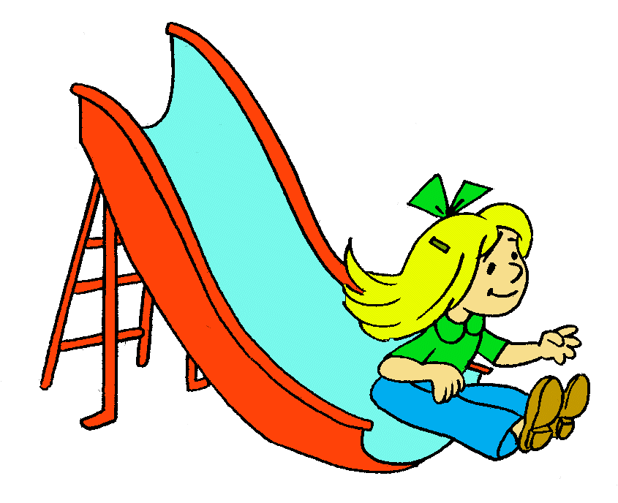
The Garden: Our garden provides the opportunity for the children to run around safely and move between inside and outside play freely whatever the weather. This outside classroom encourages the children to discover the natural world and resources as well as similar activities to indoors. They can use their bodies to climb, use ride on toys, push lawnmowers as well as use the sand pit, water play, obstacle courses, gardening and explore nature.

Front play area: We can fence off an area of the car park so that the children can continue to use the outdoors as above as well as ride on toys with more ease, puddle jump in the rain, use a variety of ball skills, and much more.

Playing is Learning
Everyone loves to play, and Busy Bees provides an environment where the children can play and learn using a variety of resources which are familiar to them as well as a range of new experiences. We encourage the children to ‘have a go’ and think for themselves whilst extending their knowledge through comments and observations. Supporting our children’s personal, social, emotional, cognitive, physical and creative development encourages them to learn through first hand experiences. Providing a wide variety of resources enables the children to choose activities which they feel are suited to their abilities as well as extending what they already know. We provide both self-chosen and adult led activities in small and large groups, free play and structured times both inside and outside.

Key Person
At Busy Bees we support the children using a ‘Key Person’ system which provides you with a member of staff who is allocated to your child. They will ensure that your child is settled each day and is the main point of contact for you to chat with both formerly and informally. They will be responsible for monitoring the progress of the children in their care, record keeping and helping to make sure there is a smooth transition between home and Busy Bees as well as when the time comes to move on to school.

Contact details
Hall phone: 01962 809918 during sessions or the Team Leader’s mobile: 07815 166687 if you are unable to reach us on the work phone.
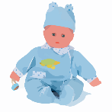
The Village Hall address is: Bishops Sutton Village Hall, Main Road, Bishops Sutton, Hampshire. SO24 0AA
Email: busybeespreschoolteam@hotmail.com
Website: busybeesbishopssutton.co.uk

Session timings

Busy Bees Pre-School meets at Bishops Sutton Village Hall during term time only. Our opening hours are as follows:-
Monday: 8.30am – 12.00pm
Tuesday: 8.30am – 2.00pm
Wednesday: 8.30am – 12.00pm
Thursday: 8.30am – 2.00pm
Friday: 8.30am – 12.00pm

We are open for approximately 38 weeks each year, 5 days a week. Our opening dates are in line with Hampshire County Council guidelines. Please check with staff, on our website, or on our noticeboard for the latest term dates. We are open from 8.30am each day. No children are permitted on the premises prior to this time, for insurance purposes, unless accompanied by a parent/carer. Flexible drop off times of 8.30, 9.00 & 9.30 enable you to drop your child off at a time that suits you best and flexible collection times on longer days (Tuesday and Thursday), enable you to choose to collect your child before lunch at 12.00, or after lunch at 1.00 or 2.00pm.

Our daily routine:
Monday/Wednesday/Friday
8.30, 9.00, 9.30am Self Registration
8.30am – 11.00am Free Play inside and out with a rolling Snack Time
11.00 – 11.15am Tidy up & pack away time
11.15am – 11.30am Quiet Time with the Register and story
11.30am – 12.00pm Music and movement/Circle time
12.00pm Children collected

Tuesday/Thursday
8.30, 9.00, 9.30am Self Registration
8.30am – 11.15am Free Play inside and out with a rolling Snack Time
11.15am – 11.30am Tidy up toys time
11.30am – 11.45am Quiet time with the Register and a story
11.45am – 12.00pm Music & movement or Circle time (some children collected at 12pm)
12.00pm – 12.40pm Lunch
12.40pm – 1.40pm Free play inside and out (some children collected at 1pm)
1.40pm – 2.00pm Tidy up & pack away time
2.00pm Children collected

Fees
We admit fee paying children from the age of 2 years, at the equivalent rate to the government funding for their age, with a minimum of 2 and a half hours per session. Fees are billed on a termly basis, but we can offer you alternatives such as half termly, monthly or weekly if that is preferred. For your child to keep his/her place at the setting, fees must be paid even if your children are absent for a short period of time as this enables their place to be kept open until their return, otherwise their place may be given to another child on our waiting list. If your child should be absent over a long period, please speak to the committee chairperson, or the treasurer.

Government funding. Government funding becomes available in the term after your child’s 2nd birthday (if the eligibility criteria is met, see below) or for all children after their 3rd birthday. The dates the funding is applied for are 1st April, 1st September and 1st January. Up to 15 hours per week at Busy Bees Pre-School will then become available free of charge, subject to the appropriate paperwork being submitted to Hampshire County Council. We also offer the extended 30-hour government funding and you can check if you are eligible by going onto the ‘Childcare Choices’ website, www.childcarechoices.gov.uk Any hours taken over the 15 funded hours for those who aren’t eligible for the 30 hours will be billed as necessary. The Pre-School staff will be able to advise on what paperwork is required, and supply this to you as necessary.
Payment of fees via a Childcare Voucher Scheme is also available upon request for the duration of the scheme being available.
Government 2 Year Funding Scheme - providing 15 hours funded provision for children who qualify for the scheme. Please speak to a member of staff to receive more information on the relevant eligibility criteria, and for help on how to apply.
Early Years Pupil Premium (EYPP) for 3 and 4 year olds is an added initiative which Busy Bees can claim for to help provide ‘improved outcomes’ for your child if you fit the criteria. To be eligible to claim parents must receive one of the following
- Income Support
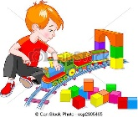
- Income based Jobseekers Allowance
- Income related Employment and Support Allowance
- Child Tax Credit (providing you are not also entitled to Working Tax Credit and have an annual gross income of no more than £16,190)
- Working Tax Credit Run-on, paid for 4 weeks after you stop qualifying for Working Tax Credit
- Support under Part VI of the Immigration and Asylum Act 1999
- The guaranteed element of State Pension Credit
Or if your child
- Has been looked after by the local authority, in care for at least one day
- Has been adopted from care
- Has left care through special guardianship
- Is subject to a child arrangements order (previously a residence order)

The Management of our setting

Busy Bees Pre-School is managed by a parent committee, whose members are elected by the parents of the children who attend the setting. The elections take place at our Annual General Meeting. The committee is responsible for:-

- Managing the settings’ finances.
- Employing and managing staff.
- Making sure the setting has, and works to, policies that help it provide a high-quality service.
- Making sure the setting works in partnership with the children’s parents.

As Busy Bees Pre-School is a ‘voluntary committee’ managed Pre-School, it is your choice as to whether you become actively involved in the group. We hold regular committee meetings and an Annual General Meeting (AGM) each year – notice of these will be posted on the noticeboards and in our fortnightly newsletter, and everyone is welcome to attend.

Busy Bees clothing

You can purchase T-shirts, sweatshirts and hats through the Pre-School – please see a member of staff for more details. Second hand uniform is also often on sale through the Pre-School. We recommend the children wear the uniform if possible, as it saves their own clothes from getting damaged, and we have found it also helps them to settle in and feel part of the Busy Bees group.

Outings
Learning through play outdoors is an essential part of young children’s development. We make full use of the garden and hard standing at Bishops Sutton Village Hall, but also aim to take the children on trips beyond the Hall’s grounds. The ratio for these outings is 1 adult to 2 children, therefore parental help is a must, and we do ask for parents to accompany us on these outings if possible.

Aims of our setting

Our setting aims to:

- Provide high quality care & learning through play for children primarily below statutory school age.
- Work in partnership with parents to help children to learn and develop.
- Add to the life and well-being of its local community.
- Offer children and their parents a service that promotes equality and values diversity.

We aim to ensure that each child:
- Is in a safe and stimulating environment.
- Is given generous care and attention, because of our enhanced ratio of qualified staff to children, as well as volunteer parent helpers.
- Has the chance to join with other children and adults to live, play, work and learn together.
- Is helped to take forward her/his learning and development by being helped to build on what she/he already knows and can do.
- Is in a setting that sees parents as partners in helping each child learn and develop.
- Is in a setting in which parents help to shape the service it offers.

Special Needs

As part of the setting’s policy we make sure that our provision meets the needs of each individual child, taking account of any special needs a child may have. The setting works to the requirements of the 1993 Education Act and The Special Education Needs Code of Practice (2000). Please speak to our Team Leader or Inclusion (Special Educational Needs Co-Ordinator) Officer – currently Sarah Jane Middleton, if you have any concerns regarding your child.

Snack and Lunch

The children are asked to bring a healthy snack in a labelled container. On lunch days they will also need a separate lunch, again in a labelled container. We ask parents to add an ice pack to boxes, as this will keep snacks and lunches fresh for the duration of the morning.

Snacks should consist of fruit or a healthy alternative. Lunches should also be healthy, and may contain sandwiches, wraps, pasta etc. We supply milk or water to drink, however if you supply your child’s drink, we ask that it be a diluted fruit juice. Please do not send any foods containing nuts, sweets or fizzy drinks as we encourage healthy eating habits at Busy Bees Pre-School.

The children can have their snacks at any point during the session and lunches are eaten sat down together at the table. This is an enjoyable, social time for the children and staff, and we find that eating together works wonders to encourage the children to try new foods.

Starting at Busy Bees
Registration

Busy Bees Pre-School is registered to accept children from 2 years to statutory school age. Upon deciding you would like to send your child to Busy Bees, you will be given an application form to complete and return. A voluntary refundable fee of £20.00 is required with your application form to secure a place at Busy Bees.
Your child will be placed on the waiting list in date of birth order (we feel this is a fairer way to operate a waiting list and therefore gives each child an equal opportunity). You are very welcome to visit the group with your child to see if you feel it is the right place for you, and before your child begins at Busy Bees we will invite you in for a couple of settling in sessions. The Team Leader will contact you during the term before your child is due to start and discuss arrangements for a possible home visit (details below) if needed, a definite start date and sessions you wish your child to attend.

Home Visits

We can arrange a home visit if you feel it would be beneficial, with the team leader and another member of staff. It can help your child to settle as they will meet us in their own environment and we can gain some knowledge of your child’s interests, likes, dislikes and any other matters you feel we should know about.

Activities and Planning for 2 Year Olds

As well as all our other activities, we also ensure that provision is made for the younger members of our Busy Bees group. Simpler versions of our activities are always on offer for these children, and we also ensure that they have a quiet area to go to should they feel tired or overwhelmed by the comings and goings of the setting. Sleep mats and blankets are available for the children to rest if they like, and we can use portable partitions within the hall to create cosy and less intimidating areas for the children to use.

Policies

Busy Bees policies are created following recommendations by the Preschool Learning Alliance and are reviewed annually. If you would like to read through them, please speak to the Team Leader or Chairperson or alternatively check the Busy Bees website.

We look forward to working and playing with your child over the coming months and years.

Best wishes from The Busy Bees Team

