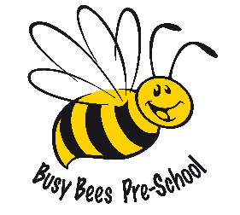
Parental declaration regarding Covid-19

At Busy Bees Preschool, we have worked hard to put systems in place that will ensure that our environments are safe places for both your children and our staff. We take this responsibility incredibly seriously but will need your assistance to ensure that we are able to maintain our safe learning environments.
We therefore ask that you complete the form below which outlines particular activities that will help to keep our setting safe.

Please can you confirm the following: | Yes | No
- I and the adult members of my household are aware of the symptoms of coronavirus (COVID-19).
- I and the adult members of my household are aware of the need to self-isolate should anyone experience the symptoms of coronavirus.
- I will notify Busy Bees as a matter of urgency should someone in my household become symptomatic.
- I understand that should my child become ill during their time at Busy Bees I or a member of my household will need to collect my child within 1 hour to minimise my child’s discomfort and to minimise the possible spread of any infection or other childhood illnesses.
- I understand that I will not be able to bring my child to Busy Bees if my child wakes with a temperature and I feel that it is necessary to reduce their symptoms by giving, for example, Calpol or any other products which contain paracetamol or ibuprofen.
- I understand that I will be asked to keep my child at home for a minimum of two weeks should my child develop some of the coronavirus symptoms whilst in the care of Busy Bees.
- I understand that during this period Busy Bees will not administer non-prescribed medication to reduce temperature as it may mask my child’s symptoms which could delay access to vital medical advice/assistance.
- I understand that Busy Bees will need to restrict the toys and items that my child brings from home to minimise the risk of infection.
- I and adult members of my household commit to following the social distancing guidance issued by the Government in our day-to-day lives.
- I understand that if I or a member of my household breaches social distancing rules in our day-to-day lives that Busy Bees can suspend my child’s place with immediate effect and that this suspension will last for a minimum of 2 weeks.
- I understand that should my child’s place be suspended and I seek out alternative provision during this period, that Busy Bees reserves the right to contact my child’s new setting to share the reason for suspension in order to protect and safeguard the children and staff in the new setting.
If you have returned from abroad within the last 14 days, please list the countries that you visited.

Name:
Signed by:
Date:

