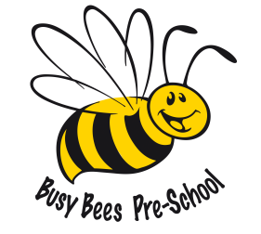

Busy Bees Preschool
Term Dates for September 2020 – July 2021

Autumn Term 7th September – 17th December 2020
1st half term Monday 7th September – Friday 23rd October 7 weeks
Half Term Break – Monday 26th October – Friday 30th October
2nd half term Monday 2nd November – Thursday 17th December 6 weeks & 4 days
CHRISTMAS HOLIDAYS – Friday 18th December – Tuesday 5th January 2021
Spring Term 6th January – 1st April 2021
1st half term Wednesday 6th January – Friday 12th February 5 weeks & 3 days
Half Term Break - Monday 15th February – Friday 19th February
2nd half term Monday 22nd February – Thursday 1st April 5 weeks & 4 days
EASTER HOLIDAYS – Friday 2nd April – Friday 16th April
Summer Term 19th April – 23rd July 2021
1st half term Monday 19th April – Friday 28th May 5 weeks & 4 days
Half Term Break – Monday 31st May – Friday 4th June
2nd half term Monday 7th June – Friday 23rd July 7 weeks
Total 38 weeks

Please note the Spring Term has a bank holiday on Friday 2nd April 2021 and the Summer Term has a bank holiday on Monday 3rd May 2021 which don’t fall within the holidays.

