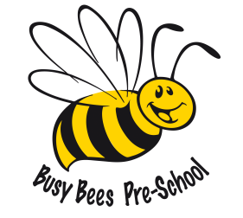

Busy Bees Preschool
Term Dates for September 2021 – July 2022

Autumn Term 6th September – 17th December 2020
1st half term Monday 6th September – Friday 22nd October 7 weeks
Half Term Break – Monday 25th October – Friday 29th October
2nd half term Monday 1st November – Thursday 16th December 6 weeks & 4 days
CHRISTMAS HOLIDAYS – Monday 20th December – Thursday 5th January 2022
Spring Term 6th January – 8th April 2022
1st half term Thursday 6th January – Friday 18th February 6 weeks & 2 days
Half Term Break - Monday 21st February – Friday 25th February
2nd half term Monday 28th February – Friday 8th April 6 weeks
EASTER HOLIDAYS – Monday 11th April – Friday 22nd April
Summer Term 25th April – 21st July 2022
1st half term Monday 25th April – Friday 27th May 5 weeks
Half Term Break – Monday 30th May – Friday 3rd June
2nd half term Monday 6th June – Thursday 21st July 6 weeks & 4 days
Total 38 weeks

Please note the Summer Term has a bank holiday on Monday 2nd May 2022 which doesn’t fall within the holiday period. We only receive funding for 38 weeks per academic year.

