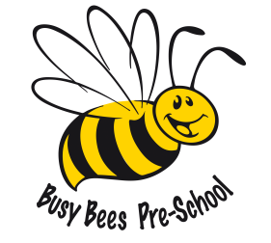

Busy Bees Preschool
Term Dates for September 2023 – July 2024

Autumn Term 4th September – 15th December 2023
1st half term Monday 4th September – Friday 20th October 7 weeks
Half Term Break – Monday 23rd October – Monday 30th October
2nd half term Tuesday 31st October – Friday 15th December 6 weeks & 4 days
CHRISTMAS HOLIDAYS – Monday 18th December – Tuesday 2nd January 2024
Spring Term 3rd January – 28th March 2024
1st half term Wednesday 3rd January – Friday 9th February 5 weeks & 3 days
Half Term Break - Monday 12th February – Friday 16th February
2nd half term Monday 19th February – Thursday 28th March 5 weeks & 4 days
(Friday 29th – Good Friday bank holiday)
EASTER HOLIDAYS – Monday 1st April – Friday 12th April
Summer Term 15th April – 19th July 2024
1st half term Monday 15th April – Friday 24th May 5 weeks & 4 days
(bank holiday Monday 6th May)
Half Term Break – Monday 27th May – Friday 31st May
2nd half term Monday 3rd June – Friday 19th July 7 weeks
Total 38 weeks
Please note the Summer Term has a bank holiday on Monday 6th May 2024 which doesn’t fall within the holiday period. We only receive funding for 38 weeks per academic year.

